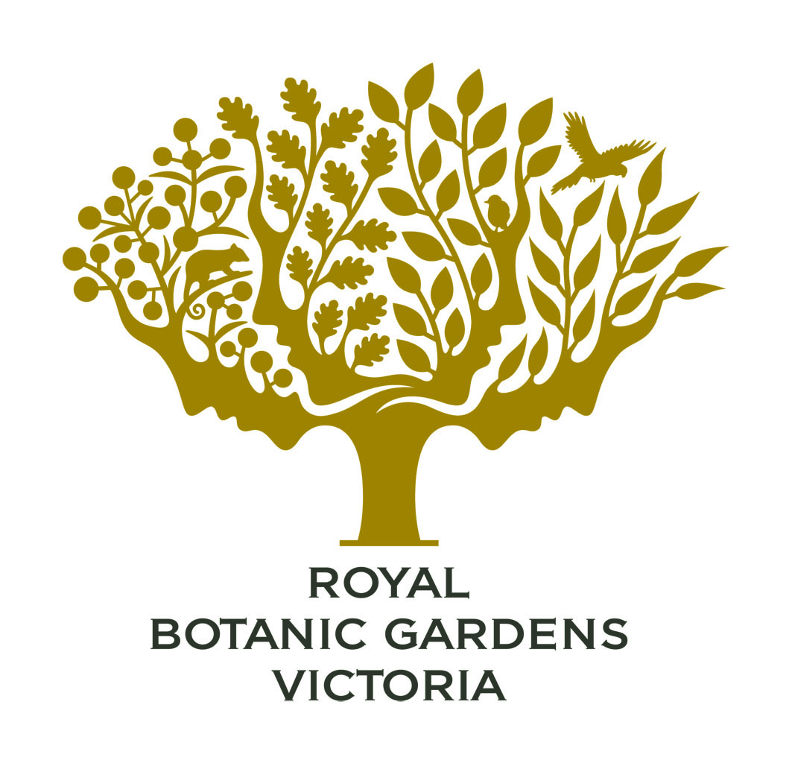

Royal Botanic Gardens Victoria
Access Action Plan 2011–2015

Table of Contents
Foreword 3
1. How to get a copy of this AAP 4
2. Legislation 5
2.1 Commonwealth Disability Discrimination Act 1992 5
2.2 Victorian Disability Act 2006 5
3. What is an AAP? 5
4. How we developed this AAP 6
5. Objectives of this AAP 6
6. Timelines of this AAP 8
7. What the RBG is currently doing to promote good access and inclusion 8
Table A - AAP Actions 9
1. Reducing barriers to persons with a disability accessing goods, services and facilities 9
2. Reducing barriers to persons with a disability obtaining and maintaining employment 12
3. Promoting inclusion and participation in the community of persons with a disability 13
4. Achieving tangible changes in attitudes and practices which discriminate against persons with a disability 14
5. How we will monitor, evaluate and update this AAP 16

Foreword
It is with pleasure that we present the first Access Action Plan (AAP) for the Royal Botanic Gardens Victoria (RBG). This plan is designed to formalise our commitment to access and inclusion and provide an effective blueprint for identifying and addressing barriers and realising new access opportunities.
The RBG is committed to providing equitable and dignified access to all stakeholders wishing to be involved in the Gardens. This incorporates identifying and removing barriers to access and inclusion across all areas of RBG operations including buildings, facilities, services, programs, communications, information and employment systems.
The RBG vision incorporates connecting people to the natural world and we recognise that these connections are valuable for people of all abilities and ages. As such, we understand that people with disabilities and access challenges should be, and are, an important focus of the RBG and its future development.
The development and implementation of this AAP provides an integral and solid planning framework from which access for all can be achieved across the whole organisation. It will support the RBG in moving forward in a proactive way, to ensure that the needs of people with a wide range of disabilities and other access challenges are considered and appropriately addressed.
It will also support the RBG in meeting its legislative responsibilities related to the Commonwealth Disability Discrimination Act 1992 and the Victorian Disability Act 2006.
Thank you to the community and RBG friends and volunteers who contributed to the development of this AAP by sharing their thoughts, ideas and experiences. Thank you also to the employees and AAP Reference Group for their input. They, together with the Board, are committed to, and excited about, the benefits and opportunities associated with the AAP development and implementation.
Ms Elaine Canty, Chairman of the Royal Botanic Gardens Board Victoria

How to get a copy of this AAP
Hard copies of this AAP are available from:
Royal Botanic Gardens Victoria
Melbourne Gardens
Visitor Centre
Birdwood Avenue
South Yarra, Victoria
Phone 9252 2300

Royal Botanic Gardens Victoria
Cranbourne Gardens
Visitor Centre
Cnr Ballarto Road and Botanic Drive, (off South Gippsland Highway)
Cranbourne, Victoria
Phone 5990 2200

Copies are available for free download from www.rbg.vic.gov.au in both PDF and MS Word formats.
Copies are available in electronic format (email or CD), large print and Braille upon request from RBG.

Legislation

2.1 Commonwealth Disability Discrimination Act 1992
- The RBG has a responsibility under the Commonwealth Disability Discrimination Act 1992 (DDA) to provide equitable and dignified access to goods and services and to premises used by the public.
- Discrimination can be both direct and indirect.

2.2 Victorian Disability Act 2006
The Victorian Disability Act 2006 (VDA) requires Victorian public sector bodies to prepare a disability action plan for the purposes of achieving the following ‘four outcome areas’:
- reducing barriers to persons with a disability accessing goods, services and facilities;
- reducing barriers to persons with a disability obtaining and maintaining employment;
- promoting inclusion and participation in the community of persons with a disability; and
- achieving tangible changes in attitudes and practices that discriminate against persons with a disability.

What is an AAP?
The AAP provides the framework for the RBG to address disability and other access issues across all areas of the organisation’s operations and to support it in meeting its requirements under the DDA and VDA.
The AAP will assist the RBG in removing existing or potential barriers and provide equity of access to premises, services, programs, information, communication and employment processes and systems. The AAP is designed to ensure that the RBG practices are proactive in relation to meeting the needs of people with disabilities and other access challenges, and that its services and facilities will be accessible to all.

How we developed this AAP
The development of the AAP was driven by an internal RBG reference group who engaged the Institute of Access Training Australia (IATA) to research and develop draft recommendations. The process involved methods that ensured that stakeholders were able to participate in the process in a way that suited their needs. This also ensured that participation was accessible and that anyone who wished to be involved could do so easily. Consultation included: development and provision of a feedback form to key disability agencies; two employee consultative workshops and a range of one-on-one interviews with staff in key service areas; an employee survey to comment on access and disability at the RBG and to provide feedback on current practice, operations and opportunities; external workshops at Cranbourne Gardens and Melbourne Gardens sites to provide opportunities for community, service agencies and RBG volunteers to comment. The collation of the information obtained from this feedback by IATA identified a range of actions, issues and opportunities relating to access across the organisation. The resulting draft AAP developed by IATA contained key recommendations, and formed the basis for the final plan prepared by the RBG Reference Group. The AAP was then approved by the Corporate Management Group and the RBG Board.

Objectives of this AAP
The objectives of the AAP link directly with the RBG vision and one of the RBG’s Strategic Goals.

Our Vision
To connect people with our natural world by advancing knowledge and understanding of the value of plants.

Key Strategic Goal 2
Engaging with our diverse community to enhance their knowledge and appreciation of nature and our Gardens through high-quality on-site and online experiences.

A key element in achieving the above goal is to ensure that the organisation is accessible to and inclusive of all people, including people with disabilities, and that the community has equitable, dignified access to all of the organisation’s services, programs and facilities, as well as its information, communication and employment systems.

In addition, the objectives also aim to ensure that people with disabilities have appropriate access to consultative processes, in order to effectively contribute to, and participate in, organisational planning and developments, to improve access for all to the RBG.

Key objectives of the AAP are:
- To confirm RBG acknowledgement of people with disabilities as an important and significant part of the community and its visitor market;
- To confirm RBG commitment to meeting the needs of people with disabilities, their families and carers as RBG stakeholders, visitors and staff;
- To provide a framework for the RBG to work towards equitable and dignified access to all areas of RBG planning, services, programs, facilities, and information, communication and employment systems;
- To promote participation and inclusiveness of people with disabilities in RBG services, events and employment;
- To work towards W3C compliance to improve the accessibility standard of the RBG website to full level A and AA standards;
- To ensure that the RBG provides reasonable assistance, adaptations and modifications to accommodate the needs of staff and volunteers with disabilities, and that staff and volunteer training courses are accessible and meet the needs of people with disability;
- To demonstrate community leadership; and
- To assist RBG to meet its legislative requirements under the DDA, VDA and other relevant legislation.

Timelines of this AAP
The timelines for AAP actions have been established taking the following into consideration: priorities as recommended by IATA; corporate priorities; future capital planning and budget planning processes.

What the RBG is currently doing to promote good access and inclusion
Employees, volunteers and community representatives engaged in the consultation identified many actions that have improved and continue to improve access for everyone. Some of these actions include:

- Facilities and infrastructure: availability of seating; well laid-out Visitor Centres; commitment to building in access in new projects; variety of accessible garden areas.
- Employment, training and volunteers: strong volunteer base of older adults who are highly valued by the organisation; disability awareness training held; Equal Employment Opportunity workshops held featuring diversity and inclusion issues.
- Information, marketing and communication: use of international symbol of access in conjunction with text and some Braille on signage; providing alternatives to PDF documents on the website; availability of a hearing loop in Mueller Hall.
- Programs, partnerships and services: availability of sensory discovery programs; availability of audio programs online; availability of wheelchair hire service at both sites.

Table A - AAP Actions

1. Reducing barriers to persons with a disability accessing goods, services and facilities
Area | Actions | Responsibility | Timelines
Infrastructure and Facilities  1.1 Equitable, dignified access to buildings and facilities | - Review the RBG access appraisal undertaken in November 2008 for Melbourne Gardens to determine and document what has been achieved, what is outstanding and what are the future priorities.  - Undertake a detailed access appraisal of the following buildings and elements at RBG Melbourne Gardens:  - Plant Craft Cottage  - Mueller Hall  - Visitor Centre.  - Undertake an access appraisal of RBG Cranbourne Gardens to provide a detailed assessment of access issues, with particular emphasis on the following buildings and elements:  - Visitor Centre  - Main step and ramp entry to Australian Garden  - Vehicle access to pick up and drop off points  - Paths of travel throughout gardens  - Woodland and Stringybark Picnic Areas  - Staff depot.  - Continue to ensure that all new project designs and plans for refurbishments, modifications and major projects are compliant with all accessibility requirements. | Director, RBG Melbourne Gardens  Infrastructure Branch (RBG)  Director, RBG Cranbourne Gardens – Cranbourne Planning Group (CPG)  Project Managers | 2012-13  2014-15  2012-13  Ongoing
1.2 Increasing people’s capacity to move around the gardens independently | - Implement a motorised people mover program as a priority at RBG Cranbourne Gardens and investigate options for introduction at RBG Melbourne Gardens.  - Review availability of seating at RBG Cranbourne Gardens particularly en route to picnic areas. | PP  PP & LMI (Cranbourne Gardens) | 2012-13  2012-13
1.3 Providing accessible furniture and infrastructure | - Investigate options for the inclusion of an adult change facility with hoist tracking system at RBG Cranbourne Gardens. | PP & LM&I (Cranbourne Gardens) | 2011-12
Information, Communication and Marketing  1.4 Emergency Management Procedures | - Ensure that both audible and visible information systems are provided in relation to emergency management procedures at both Melbourne Gardens and Cranbourne Gardens.  Incorporate visual cues such as easy-to-read text on screens, visible emergency alarms in offices and facilities to assist people with hearing impairment. | LM&I (Cranbourne Gardens)  Infrastructure (Melbourne Gardens)  LM&I (Cranbourne Gardens) | 2013-14 (Cranbourne Gardens)  2014-15 (Melbourne Gardens)  2013
Signage  1.5 Effective accessible signage to enable access and inform visitors | - Review existing signage and way finding strategies and prepare a gap analysis. Consider consistency of signage (both internal and external) and include pictures and symbols, Braille and tactile components, where necessary. Font types and print sizes should also be considered to support users with a range of disabilities, including vision impairment. Consider interactive options also.  - Ensure directional signage is clear and consistent and provides accurate information to routes and destinations, including distances from car parks to entry, drop off points and key locations within gardens. | PP & Infrastructure (Melbourne Gardens)  PP & Infrastructure (Melbourne Gardens) | 2013-14  2014-15
Mobility Information  1.6 Ensure Mobility information is included in visitor information (how to get into and around the RBG) | - Include mobility map information in general map brochures.  b) Make the mobility information for both sites available on the RBG website. | PP (Melbourne Gardens) (Cranbourne Gardens) & M&C  IS | 2012-13  2012-13
Online Communication  1.7 Ensure the RBG website and other online communications are accessible to everyone and to enhance accessibility features of the RBG website | - Develop an ‘accessibility index’ page that will be a centralised reference point for all accessibility information available on the RBG website. Ensure that a link to the ‘accessibility index’ is present and easily located on all RBG website pages. | IS | 2013-14

2. Reducing barriers to persons with a disability obtaining and maintaining employment
Area | Actions | Responsibility | Timelines
Employees  2.1 Ensure RBG  recruitment policies and practices are accessible and meet the needs of people with disabilities | - Ensure that position descriptions can be provided in accessible formats on request.  - Ensure that staff involved in recruitment and selection of staff are trained in the responsibilities of the RBG as an EEO employer and have undertaken disability awareness training. | HR & IS  HR | 2012  2013
2.2 Ensure that any third party operators and contractors are familiar with the objectives of the DDA and the RBG AAP | - Develop guidelines for contractors working at RBG that detail the RBG’s commitment to and expectations of accessibility.  - Provide RBG tenants with a copy of the RBG AAP, which outlines our objectives.  - Amend tenant Policy and Protocol Manuals (where applicable) to include reference to the DDA’s objectives for subcontractors. | Infrastructure (Melbourne Gardens), LM&I (Cranbourne Gardens)  Co-ordinator, Leasing  Co-ordinator, Leasing | 2012-13 (Melbourne Gardens)  2011-12 (Cranbourne Gardens)  2011-12  2012-13

3. Promoting inclusion and participation in the community of persons with a disability
Area | Actions | Responsibility | Timelines
Programs, Partnerships and Services  3.1 Providing experiences and connections to the RBG through programs, partnerships and services | - Continue to develop the school partnership between RBG Cranbourne Gardens and Peninsula Special Developmental School to facilitate community development, innovative service delivery and educational experiences.  - Continue existing tailored experiences, such as sensory gardens, and develop appropriate new experiences. | PP (Cranbourne Gardens)  PP (Melbourne and Cranbourne Gardens)  Horticulture (Melbourne and Cranbourne Gardens) | Ongoing  Ongoing
3.2 Access to events and programs | - Ensure all visitor events are accessible and inclusive. Embed process in event planning and incorporate the following:  - Accessible venues and spaces;  - Advertised in accessible formats. | PP & IS | 2012-13
Volunteers  3.3 Providing opportunity for people with disabilities to participate in RBG volunteer program and supporting their involvement | - Ensure that selection committees are trained in the responsibilities of the RBG as an Equal Opportunity Employer and have undertaken disability awareness training.  - Ensure that volunteer roles and positions are advertised broadly and information can be accessed in different formats if required.  - Provide reasonable assistance and adaptations to accommodate the needs of volunteers with disabilities. | All  Co-ordinators, Volunteers  Co-ordinators, Volunteers | Ongoing  2011-12  Ongoing

4. Achieving tangible changes in attitudes and practices which discriminate against persons with a disability
Area | Actions | Responsibility | Timelines
Resources  4.1 Ensure that implementation of the AAP is appropriately resourced and funded on an ongoing basis | - Consider the implementation costs of the AAP in the annual budget and planning process and allocate funds to support ongoing access priorities and improvements. | CMG | Annually
Creating a culture of access  4.2 Developing a whole-of-organisation commitment to AAP implementation and an understanding of staff and Board responsibilities | - Once approved by the Reference Group and Board, launch the AAP to the broader employee and volunteer groups, highlighting the access achievements of the organisation to date, as well as the key priorities for the future.  - Ensure the AAP is integrated with the broad RBG planning frameworks and policies, for example, the Corporate Plan and Annual Business Plans.  - Ensure AAP actions and key priorities are considered as part of divisional and branch RBG plans, where appropriate. | Project Director, AAP (EEO Chair)  Project Director, AAP (EEO Chair)  CMG | 2011-12  Annually/Ongoing  Ongoing
Training and Professional Development  4.3 Developing the capacity of people in RBG to proactively address access issues and opportunities | - Ensure that general disability access awareness training is provided to all employees and volunteers on a regular basis. | HR & Co-ordinators, Volunteers | 2013-14
Legend: BMG – Branch Managers Group; CMG – Corporate Management Group; EEO – Equal Employment Opportunity; HR – Human Resources; IS – Information Services; PP – Public Programs; LM&I – Land Management and Infrastructure; M&C – Marketing and Communications; IS – Information Services;

5. How we will monitor, evaluate and update this AAP
This AAP will be monitored, reviewed and updated as follows:
- Update report from Branch Managers to the relevant Director every six months in relation to progress of actions in their areas of responsibility;
- Annual report to the RBG Board regarding the status of all actions identified within the AAP;
- Use of the Reference Group to undertake an audit and review the AAP during 2014-15 and to develop an updated AAP.
The Australian Human Rights Commission (AHRC) notes that an AAP is not a static document, but changes according to practices, review and evaluation. The AHRC describes 'reviewing’ as the process of assessing and revising the AAP.

